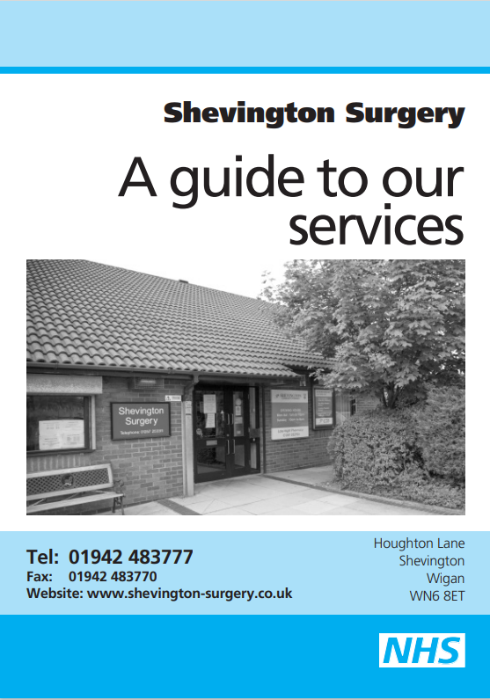

Houghton Lane

Shevington

Wigan

WN6 8ET

Telephone: 01942 367420

Website: [www.shevingtonsurgery.nhs.uk](http://www.shevingtonsurgery.nhs.uk)

# Welcome to Shevington Surgery

# 

Shevington Surgery serves the villages of Shevington, Appley Bridge, Standish, Standish-Lower-Ground, and parts of Wrightington.

Our team includes 5 GPs, an Advanced Practitioner (Nurse), an Advanced Practitioner (Paramedic), 3 Physician Associates, Practice Pharmacist, Practice Manager, Deputy Practice Manager, Office Manager, Practice Nurse Manager, Quality Lead, 5 Practice Nurses, 2 Health Care Assistants and a full complement of administrative, and reception staff.

We offer a full general practice service and run specialist clinics for children, pregnant women, patients needing minor surgery (joint injections only), family planning including contraceptive implant fitting and cervical cytology.

Shevington Surgery is also a ‘training practice’. This means that at times, Doctors in various stages of training to be a GP spend some months with us in order to gain the experience they need to become family doctors. We are also a nurse training practice for BSc Students, cytology students and nurses new to General Practice.

The surgery operates from purpose-built premises with in-house pharmacy and access for the disabled and parking facilities.

This leaflet is for both existing patients and those considering registering with us. It tells you about our services, how to access them and some general information about how our practice operates.

**How to register**

If you live in our practice area and would like to register with us, please collect a registration pack available from our reception. Information on how to register is also available on our website [www.shevingtonsurgery.nhs.uk](http://www.shevingtonsurgery.nhs.uk). You will be registered with the practice and allocated a named accountable GP who will be responsible for coordination of your care. If you have a preference of your named accountable GP, please let us know and we will make all reasonable efforts to accommodate your request. Although you will be allocated a named GP this does not prevent you from seeing any of the Clinicians at the surgery.

You are free to express a preference of practitioner when making an appointment, but it may not always be possible to see the practitioner of your choice.

# Our Practice Area

Details of our practice boundary and our live map are on our website [www.shevingtonsurgery.nhs.uk](http://www.shevingtonsurgery.nhs.uk).

If you need any additional help with this please speak to our Reception team.

# Introducing Your Health Team

## **The Partners**

Dr Lisa Madalein Jharna Bose (female)

MB ChB (1991 Liverpool)

Dr Allan Fairhurst-Winstanley (male)

MB ChB (1992 Manchester) FRCGP DRCOG

Dr Christopher John Lancaster (male)

MB BS (1993 London) MRCGP DRCOG

## Dr David Anthony Humphreys (male)

BSc Hons (1997 St Andrews) MB ChB (2000 Manchester)

MRCGP DRCOG

## Dr Melanie Jane Carver (female)

MB ChB (2005 Sheffield) MRCGP

Carolyn Sharrock (female)

PGDIP

**Other Clinical Staff**

**Advanced Practitioner**

Sarah MSc, BSc, HCPC

**Physician Associates**

John

Matthew

Doug

**Practice Pharmacist**

Becky, MPharm

**Nursing Team**

## **Practice Nurse Manager**

Gemma RGN BSc

## **Practice Nurses**

Rebecca RGN MSc

Michelle RGN

Sarah RGN BSc

Emilie RGN

Hannah RGN

## **Senior Health Care Assistant**

Angela

**Health Care Assistant**

Andrea

## **Management**

## **Practice Manager**

Kerry

**Deputy Practice Manager**

Stacey

**Office Manager**

Andrea

**Quality Lead**

Amy

**Admin Team**

Amy, Laura, Kathryn, Katrina, Lorraine, Hilary, Claire, Joanne, Jackie, Nicola, Karen, Anneliese, Joanne, Emma, Ellie

## **Community Staff**

## **District Nurses**

The District Nurses are specially trained nurses who work in the community.

## **Health Visitors**

The Health Visitors work with families with young children. Telephone 01942 483605 (for routine appointments only).

## **Midwives**

The midwives will look after you during your pregnancy and postnatal. Midwives are self-referral at: <https://www.wwl.nhs.uk/maternity-self-referral-form>

**Community Matron**

The Community Matron is involved in the care of patients with multiple complex needs.

**Community Link Worker**

The Community Link Worker signposts patients to other services available within the Borough to enable them to self-manage their care.

**Care Co-Ordinators**

Care Co-Ordinators – services include support in co-ordinating appointments, support in attending appointments and guidance on the use of medication.

**Healthy Routes**

Offer free confidential support to help patients quit smoking, drink less, be more active, lose weight and feel better about themselves.

Contact the team on 01942 836963

**Surgery Hours**

The surgery is open as follows: -

Monday to Fridays 08:00am to 06:30pm

Saturdays (1 in 4) 08:00am to 12:00noon

The Telephones are answered as follows: -

Monday to Fridays 08:00 to 06:30pm

### When the Surgery is Closed

Please ring **01942 367420** and an answering machine will advise you.

If you require urgent medical assistance that cannot wait until the surgery re-opens, please dial 111. Calls to NHS 111 are free from both landlines and mobiles.

If you have a life-threatening medical emergency, please dial 999.

**Appointments**

We use the AskmyGP system to manage our appointment requests. The system is open Monday to Friday from 07:30am to 10:00am. All requests will be triaged by a GP or Clinician, who will decide if the request is URGENT or ROUTINE.

URGENT requests will be dealt with on the day and patients will be contacted and offered an appointment, either telephone or face to face.

ROUTINE requests will be contacted and offered an appointment, either telephone or face to face, within the next few weeks.

Appointments will be offered with the most appropriate person for your condition, and you may be offered an appointment with a Doctor, Advanced Practitioner, Physician Associate, Nurse, or Health Care Assistant.

After 10:00am, if you need URGENT medical advice before the next working day, within surgery opening hours (up until 06:30pm), please contact the surgery on **01942 367420.** Requests for children aged 12 and under after 10:00am should also be directed to the surgery via telephone or face to face. These requests will also be triaged and dealt with as clinically appropriate.

Routine appointments are also available via the Extended Access Service. These can be booked by contacting 01942 482848.

You may be asked some questions when you contact the surgery to make an appointment. This is so that requests can be triaged appropriately.

**Text Messaging Service**

We use a text messaging service whereby we can send you reminders regarding appointments and health promotion campaigns. You can also cancel appointments by replying to your reminder. We find this service highly effective and allows us to reach a high population to promote services available and gather information to improve your health. If you do not wish to use this service, please advise the staff to allow us to opt you out.

**Missed appointments - DNA’s**

Please cancel any unwanted appointments so that these can be offered to other patients. Whenever possible 24 hours’ notice should be given. We will write to you if you DNA and you may be removed from our practice list if you persistently DNA appointments. Our DNA policy is available on our website [www.shevington-surgery.co.uk](http://www.shevington-surgery.co.uk) under the Practice Policies section.

# Home Visits

We can visit you at home if you are housebound or unable to attend the surgery. Please ring **before 10:00 am** to request a visit. Emergency requests will be accepted between 08:00am and 06:30pm (Monday to Friday).

**Please only request a home visit if you cannot get to the surgery.**

**Repeat Prescriptions**

These are available after being authorised by the Doctor or Clinician who initiates treatment. This ensures correct dosage and a 28-day supply of medication.

Prescriptions can be requested as follows: -

* by ticking the items, you require on the computer slip and returning to the surgery
* by letter
* in person
* via the internet using Patient Access (**please register at reception to use this service)**
* via telephone by choosing option 2 between the hours of 10:00am and 06:30pm Monday to Friday.

Prescriptions can be collected 2 working days after request or posted to you if a stamped addressed envelope is supplied. We are also using EPS (electronic prescription service) and if you have a nominated pharmacy your prescription will automatically be sent to your nominated pharmacy.

We have an in-house pharmacy Shevington Community Pharmacy which is open from 08:00am to 06:30pm Monday to Friday and from 08:00am to 04:00pm on Saturdays.

Tel: 01257 252753

There are also three other local pharmacies:

Manor Pharmacy Tel: 01257 254142

Appley Bridge Pharmacy Tel: 01257 252555

All the pharmacies provide a collection and delivery service, and you should contact them directly to arrange this.

# Please allow at least 48 hours’ notice (2 working days) for prescription requests

**Practice Pharmacist**

We have a practice pharmacist working at the surgery who carries out routine medication reviews on behalf of the GP’s. He also reviews hospital discharge and out-patient letters for medication changes so that patient records can be updated as quickly as possible.

When your annual medication review is due you will be invited to the surgery to see either the Practice Pharmacist or your GP depending on your medical condition.

**Clinics Available at the Surgery**

**Postnatal clinic**

**Tuesday 02:30pm to 05:00pm**

The postnatal clinic is held by one of our GPs.

**Baby immunisation clinic**

**Tuesday 01:30pm to 06:00pm**

The immunisation clinic is run by our practice nurses.

**Cervical cytology**

We offer smear appointments throughout the week.

Smear tests are also available at other local practices and also within the extended access service. Contact the surgery to book an appointment.

Appointments can also be arranged at other times.

#### PERSONAL EXAMINATIONS

If your medical condition is of an intimate nature and you would prefer a male or female doctor, the staff will always try to accommodate your request. You will be offered a chaperone if appropriate.

#### Practice Nurse Team

Our nursing team includes 1 Practice Nurse Manager, 1 Quality Nurse Manager, 5 Practice Nurses, and 2 Health Care Assistants. Our Nurses are highly skilled health care professionals who are able to deal with a wide range of conditions and health concerns. They are experts in many areas of disease management such as diabetes and asthma.

**If you need an appointment for any of the following, please contact the surgery to arrange:**

* Family planning/contraceptive implants
* HRT
* Vaccinations
* Travel vaccinations/advice
* Cervical smears
* Asthma/COPD reviews
* Diabetic review
* Thyroid monitoring
* Heart Disease monitoring
* BP monitoring
* Well woman check
* Well man check
* Rheumatoid review
* Cholesterol monitoring

**If you need an appointment for any of the following, please contact the surgery to arrange:**

* New registration check
* Elderly assessment
* BP check
* ECG
* Weight check/dietary advice

**HOW TO ARRANGE BLOOD TESTS**

Blood tests are available at various clinics. To book a test please:

Telephone 0300 555 4567 or book online at [www.wwl.nhs.uk/phlebotomy](http://www.wwl.nhs.uk/phlebotomy)

**HOW TO OBTAIN YOUR TEST RESULTS**

Please ensure you have waited at least 5 working days before contacting the surgery regarding test results. If you are due to attend for a regular review, you do not need to ring for your results as these will be discussed with you at your review appointment.

For all other results please contact the surgery

Monday, Tuesday, Thursday, and Fridays:

10:00am to 12:00noon or 02:00pm to 04:00pm

Wednesdays: 10:00am to 12:00noon

Please note, only results for tests we request will be returned to us.

Results are not always available over the telephone and may require an appointment with a Clinician to discuss further.

**Due to confidentiality results will normally only be given direct to the patient, unless under 16 years of age or we have written consent from the patient to authorise this.**

**Our Commitment to you**

As part of our service, we as your health team can offer you:

* An appointment with a Doctor, Clinician, or nurse of your preference, subject to availability
* A range of services with our clinical team subject to availability
* High standards of care
* For **urgent** cases an appointment on the same day
* We will endeavour to start surgeries on time
* You will be informed of any unavoidable delays that occur
* You will be treated with courtesy and efficiency by our staff, who will, at all times, endeavour to respect your privacy and dignity
* A clean and comfortable waiting area
* Waiting times to be kept to a minimum
* You will be asked if a junior doctor/student may attend your consultation, and you will always have the right to refuse
* A chaperone will be available on request
* Letters of referral will be despatched or ready for collection within two working days of dictation
* Repeat prescriptions will be available within 2 working days
* A home visit will be available if you are unable to get to surgery because of your illness
* Complete confidentiality at all times of patient records and consultations
* Facilities for the disabled

**In Return for these services, we would ask that you help us by:**

* Being on time for your appointment
* Letting us know if you need to cancel
* Requesting a home visit before 10:00am.
* Ringing for results after 10:00am.
* Giving at least 48 hours’ (2 working days) notice on requesting a repeat prescription.
* Accepting that there could be some delay if your Clinician has to attend an emergency.
* Accepting that there may be some waiting time as some patients may need more consultation time than others – one day that person might be you!
* Refraining from smoking in and around the surgery. This includes the use of e-cigarettes.
* Refraining from bringing animals into the surgery (except assistance dogs).
* Keeping your children under control, so as not to cause distress to, or disturb other patients who may be feeling unwell, and to protect their own safety.
* Seeing your usual Clinician at the surgery whenever possible.
* Not causing an obstruction with your vehicle. This includes parking in the drop of zones which is required for emergency vehicles.

**ZERO TOLERANCE**

We aim to treat our patients courteously at all times and in return expect our patients to treat our staff in the same way. The practice staff have the right to care for others without fear of violence or abuse. We take seriously any threatening, abusive or violent behaviour against any of our staff or patients. If a patient is violent or abusive, they will be warned to stop their behaviour. If they persist, we may exercise our right to have them removed from our list immediately.

**Comments and complaints**

We aim to give a friendly and professional service to all our patients. However, if you have any complaint or concern about any aspect of our service, please let us know.

A copy of the Practice Complaints Procedure is available from the reception or on our website. This outlines the procedure to follow should you wish to make a complaint

We are always looking for ways in which to improve the standard of our services and would appreciate any ideas, comments, or suggestions you may have.

We conduct regular Friends and Family test surveys within the surgery and review the results with our PPG. We also carry out annual patient surveys to gain feedback from patients to allow us to monitor our services and continuously strive to improve our standards.

**Patient Participation Group (PPG)**

We have a very active and supportive Patient Participation Group (PPG). Their role is to represent our patients to enable them to have an input into the future development of the practice and the services that it provides.

There is a PPG noticeboard within the surgery and feedback cards are available for completion. The PPG can also be contacted at: [Shevington.ppg@hotmail.co.uk](mailto:Shevington.ppg@hotmail.co.uk)

**Patient Confidentiality**

We respect your right to privacy and keep all your health information confidential and secure. We ask for information about you so that you can receive the best possible care and treatment. We keep this information, together with details of your care, to ensure that the doctors and/or nurses have accurate and up-to-date information.

There are times when we have to pass on information to other agencies such as hospitals, social services, community services and other health care agencies. This is always done in confidence or, by removing identifying details, when these are not essential.

A copy of our Privacy notice is available on our website

[www.shevingtonsurgery.nhs.uk](http://www.shevingtonsurgery.nhs.uk) or can be requested in person at the surgery.

**Your Data Matters to the NHS**

Information about your health and care helps us to improve your individual care, speed up diagnosis, plan your local services and research new treatments.

In May 2018, the strict rules about how this data can and cannot be used were strengthened. The NHS is committed to keeping patient information safe and always being clear about how it is used.

You can choose whether your confidential patient information is used for research and planning.

To find out more visit: [www.nhs.uk/your-nhs-data-matter](http://www.nhs.uk/your-nhs-data-matter)

**Completion of Forms/medical reports**

If you require any forms to be completed or signed, you DO NOT need to make an appointment with the Clinician. Simply leave the form at reception and the staff will give this to the appropriate doctor. If necessary, the doctor will contact you to clarify any details or may request you to make an appointment.

A fee is payable for completion of private insurance and medical forms and a list of our current fees is displayed in the surgery. You will normally be informed of the fee when you leave the form at reception.

# Requests for your health details

### Travel insurance

More and more insurance companies are asking for your health information when booking holiday cover.

If you have any doubt about the significance of a specific area of your medical history, check with your usual Clinician at an appointment, before completing the form.

### Solicitors’ Letters

When a solicitor acting on your behalf asks for medical evidence, it is usual professional etiquette for him/her to write to your GP/Clinician, stating the information required and including your written consent for the release of the information. ‘To whom it may concern’ letters will only be provided in exceptional circumstances after due consultation with your usual doctor.

### Housing References

The borough housing department have long since refused to consider letters in support of an individual’s application. Our practice policy is not to write housing reports as a consequence.

# Accessible Information

If you have any language barriers or communication needs, please let us know. We are able to provide interpreters or information in large print or braille if required.

**Military Veterans**

If you are a military veteran and previously served in the armed forces or reserve forces, please let us know so that we can note this in your records.

We are also keen to know if you are a family member of a military veteran. Please let your GP, healthcare professional or the reception team know if you would like us to note this information in your record.

**Online Access – The NHS APP**

The NHS App gives you a simple and secure way to access a range of NHS services including:

* Ordering your repeat prescriptions and nominate a pharmacy where you would like to collect them from.
* View your GP health record to see information like allergies, medication, test results, referrals, and medical history.
* Receive messaged from the surgery about appointments, including self-book options.
* Register your organ donation decision.
* Choose how the NHS uses your data.
* View your NHS number.
* Use NHS 111 online to answer questions and get instant advice of medical help near you.

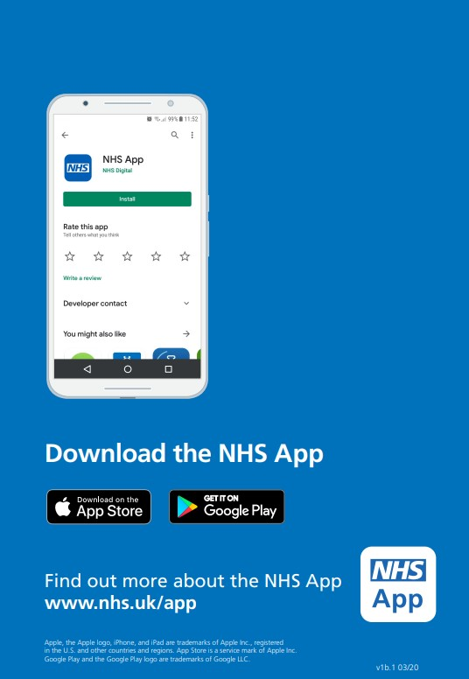

# Other Local NHS Services

As well as our practice there are many other local NHS services you can contact for health advice, information, or treatment. Before you do, remember that you can treat many minor ailments such as colds, coughs, and indigestion by keeping a well-stocked medicine cabinet at home.

### NHS Walk-in Centres

You can see an experienced nurse for treatment of minor injuries and illnesses, seven days a week.

**Leigh NHS Walk-in Centre** - The Avenue, Leigh

Tel: 01942 483453

07:00am to 09:00pm 7 days a week

**Skelmersdale NHS Walk-in Centre** - The Concourse, Skelmersdale

Tel: 01695 554260

07:00am to 09:00pm Monday to Friday

09:00am to 05:00pm Saturday and Sunday

**NHS 111 - Out of Hours Service**

If you need medical assistance when the surgery is closed, please call 111 for advice.

**Your Local Pharmacist**

Your local Pharmacist will be able to give you free health advice at any time. They may also be able to offer treatment free of charge under the Minor Ailments Scheme.

### Accident and emergency 999

In an emergency, go to your nearest accident and emergency department or call **999.** Accident and emergency departments are open 24 hours a day, 365 days a year and can assess serious injuries and provide emergency treatment.

**NHS England**

NHS England commissions health services nationally.

NHS England can be contacted at:

NHS England

PO Box 16738

Redditch

B97 9PT

**Telephone: 0300 311 22 33**

(08:00am to 06:00pm Monday to Friday, excluding Bank Holidays)

[england.contactus@nhs.net](mailto:england.contactus@nhs.net)

**Practice Website**

[www.shevingtonsurgery.nhs.uk](http://www.shevingtonsurgery.nhs.uk)

****<https://www.facebook.com/shevingtonsurgery>





